**Career Roadmaps**

*Submitted in partial fulfillment of the requirements for the award of the degree of*

# Bachelor of Computer Applications

## To

Guru Gobind Singh Indraprastha University, Delhi

**Guide: Submitted by:**

Dr. Sandhya Maitra Kunal Goyal

Associate Professor (IITM) 03421102019

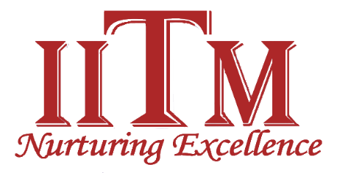

# Institute of Information Technology & Management, New Delhi – 110058

**Batch (2019-2022)**

Briefing about Minor Project

# Title of project

The title of the project is “Career Roadmaps” to move towards the technology in the right direction.

**Problems with the Existing System**

Every student in their first step of career faces problems when choosing a technology regarding which technology to choose, what are the features available in the particular technology, which technology is easiest to learn, which is the best technology in terms of the future growth as per the market trends. But there’s no such right and trustworthy information and resources available together at one place.

However, it is easy to choose the technology but it is difficult to move in the right direction in every technology.

Therefore, every student also faces problems after choosing a technology such as:

* What to be learned in that technology?
* How to learn the technology?
* How to move in the right direction?
* How to grow in the particular technology?
* How much time it would take to learn the technology?
* From what point we should start learning the technology?
* Where are the best resources available for that technology?
* Is technology chosen by me is right or not?

So here comes the role of **Roadmaps** in building the career. A Roadmap is very important aspect in one’s career to follow the right path so that one can achieve their goals effectively and efficiently in the right manner.

# Description of the Proposed System

# A Roadmap is a visual flowchart or any other visual representation of data that helps one to get all the information required to move towards the right direction of the chosen technology.

# Career Roadmaps will help everyone to set the right path to achieve their goals and success by choosing a right technology. Career Roadmaps will provide complete roadmaps about every technology and covers every important aspect what is right for you. Career Roadmaps is not just limited to people belonging to technical background but as well as it will help everyone whether you belong to artist background or designing background or any other aspect.

# Description and identification of the Functional Modules

# Elements in the Functional Modules:

# Field

# Technology

# Area of Work

# Contact us

# Login

# Sign up

# Field Module

# Field Module lists the various types of career fields such as Development, Graphics Designing, Software Testing, Networking Engineer, Hardware and IT and many more. You can select the field from the given options in which you want to build your career.

# Technology Module

# Technology Module is a subcategory of the Field Module. It lists the various kinds of technologies under the fields mentioned above such as Web Development, App Development, Java Developer, Python Developer, Machine Learning, Artificial Intelligence, Designing, Motion Graphics and Animation, Manual and Automation Software Testing and many more. You can choose your technology in which you want to move ahead in your career according to the chosen field at the first step.

# Area of Work Module

# This Module is a subcategory of the Technology Module. It helps you choose a right area of the different technologies as mentioned above such as Front End, Back End or Full Stack, Vectors and Illustrations in 2D or 3D, Animation and Motion Graphics in 2D or 3D, 3D Modelling or Character Designing, Selenium with Python or JAVA, Database Testing, GUI Testing, Penetration Testing, Performance Testing and many more. You can choose the right area of work as per your above chosen technology and field. It will provide you all the necessary information and Roadmaps and also the resources available to learn the technologies.

# Contact us Module

# Contact us Module allows end users to send queries to the admin for any support regarding course materials, roadmaps, guidance and any other technical information or study material.

# Login Module

# Login Module allows users to login to the career roadmaps and become a verified and known user to the career roadmaps which helps them to save their favorite courses, technologies and roadmaps and other study material.

# Sign up Module

# Sign up Module is for new users to become a partner to career roadmaps for a better future, registered users gets more perks and advantages as compared to regular users like favorite courses, roadmaps, study material and much more.

# Methodology

1. **SDLC Model to be used:**

**Prototype Model:**

The Prototype Model is the advancement of the older Models as the problem with the older models is that the Customer cannot see the working project till the end of the development process which can lead to project failure, thus it is better to use Prototype model so that the customer can take a look at the working prototype during the development process.

In this model, the sequence of activities performed in a software development project area: -

* Requirements gathering and analysis
* Quick design
* Build prototype
* User evaluation
* Refining prototype
* 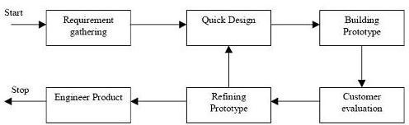Engineer product

**Figure1.1: Prototype model**

**Justification of the selection of Model**

The Prototype Model solves the problems that are associated with the older models as in the older model customer cannot take a look at the working prototype during the development process thus in such situations prototype model can help as in this model first a working prototype is built that gives the user a idea about the final product and evaluates the final product with the working prototype and suggest the changes and modifications in the product this bridges a gap between the developer and the customer and leads to successful development of the product.

**Tools**

The Hardware Requirement Specifications: -

|  |  |
| --- | --- |
| Minimum Requirements | |
| Processor | Intel(R) Core (TM) i5 CPU |
| CPU | 3.20 GHz |
| Memory | 6 GB |
| Hard Disk | 500 GB |
| Display | Super VGA (1366*×* 768) or higher-resolution monitor  with 256 colors |
| Input Device | Keyboard, Mouse |

# Table No-1.1: Hardware Requirements

The Software Requirement Specifications: -

|  |  |
| --- | --- |
| Languages | HTML, CSS, JavaScript, |
| Framework | Bootstrap, jQuery, Express JS, Node JS, React JS |
| Database | Mongo DB |
| Software | VS (Visual Studio) Code |
| Operating System | Windows OS |

# Table No-1.2: Software Requirements

**Future Scope**

* Reliability as all the data and information mentioned on the Website is Secure and Trustworthy.
* Easy to maintain and manage.
* Nice user-friendly environment.
* Local accessibility of materials such as Roadmaps.
* Publicly web based accessible application with responsive screens so that user can easily access over the various devices such as Laptop, Tablet and Smart Phone.
* Proper management of information, Roadmaps and Resources.
* Connection with the various Courses and other Technical Web Services available.
* Students can take counselling from the online developers available.